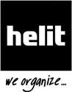
H61058

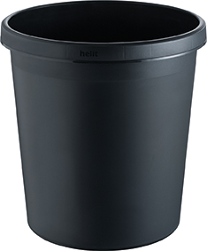
"the german" waste bin

the helit waste bins are available in different colours and
volumes so that the right one can be selected for every need
and taste

the available litter inserts (with or without lid) are ideal
for waste separation

with separately available attachment rings in 2 colors,
the waste bin liner can be fixed

with surrounding handling rim

we recommend a waste bin liner of 35 l

Product features |  | Shipping information
SKU: | H61058 | PU width: | 347 mm
Colour ref: | 95 | PU depth: | 347 mm
EAN: | 4012086052510 | VE height: | 480 mm
HS code: | 39261000 | Pallet width: | 800 mm
Material: | high-quality, shockproof plastic | Pallet depth: | 1200 mm
Ø upper: | 315 mm | Pallet height: | 1750 mm
height: | 335 mm | Packing unit: | 6
inner upper Ø: | 293 mm | Pallet quantity: | 480
Content volume: | 18 litres

helit innovative Büroprodukte GmbH

Osemundstraße 23-25
58566 Kierspe

Tel.: +49 (0) 2359 - 905 - 0
Fax.: +49 (0) 2359 - 905 - 220
Email: info@helit.de
Web: www.helit.de

